

Subject: Programming with Java
ASSIGNMENT No : 11
TITLE :Write a Java program to demonstrate the implementation of interfaces.
Name:Avdhoot Mohite Class:CSE A3
PRN:25070122056 Batch:25-29
Problem Statement
Write a Java program to demonstrate the implementation of interfaces.
Learning Objectives
To implement interfaces for achieving abstraction and multiple inheritance of type.
Theory
An interface specifies a set of abstract methods that implementing classes must define. It provides complete abstraction and supports multiple inheritance of type. Interfaces improve modularity, loose coupling, and software flexibility. They allow different classes to implement common behavior while maintaining independent implementations. Interfaces are widely used in enterprise application development.
Outcome
After completing this experiment, we learned how to implement interfaces in Java. We understood how interfaces provide abstraction by defining methods that must be implemented by classes. The experiment improved our understanding of code reusability, loose coupling, and multiple inheritance of type in object-oriented programming.
Conclusion
The experiment successfully demonstrated the implementation of interfaces in Java. It showed how interfaces define a common contract that different classes can implement according to their requirements. Using interfaces improves code flexibility, modularity, maintainability, and supports abstraction, making Java applications more scalable and reusable.
Exercise
1.Create an interface Printable and implement it in Student and Employee classes

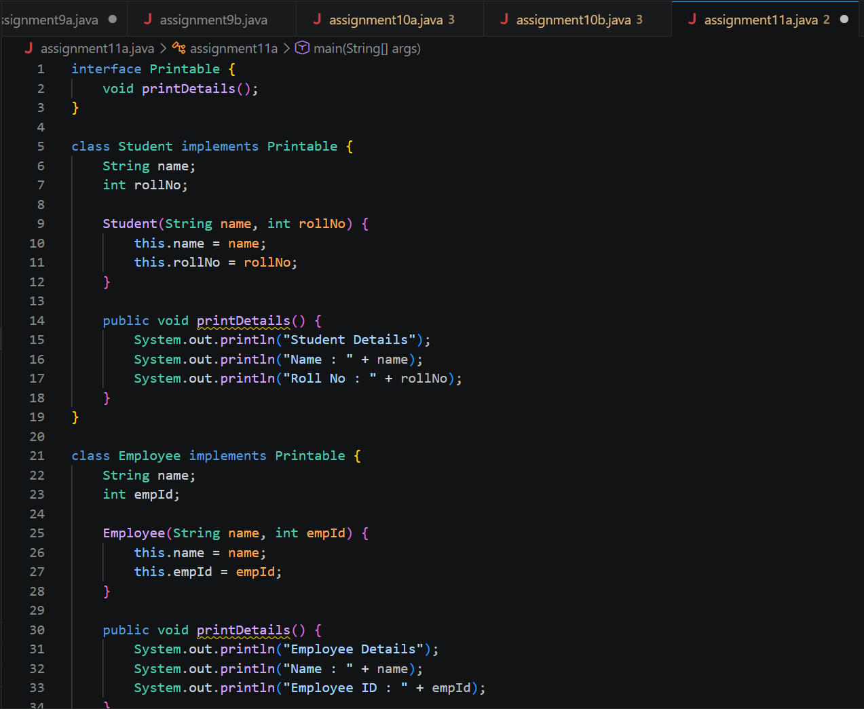
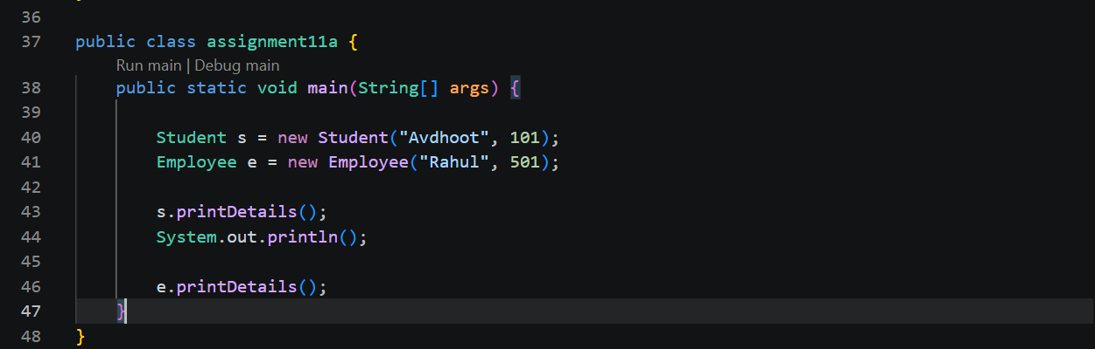
Output:
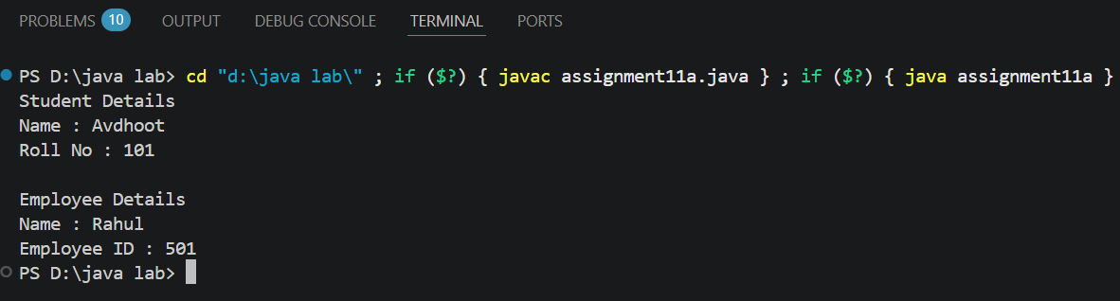
2.Create an interface Switchable with a method turnOn(). Implement the interface in Light and Fan classes to display the device status.
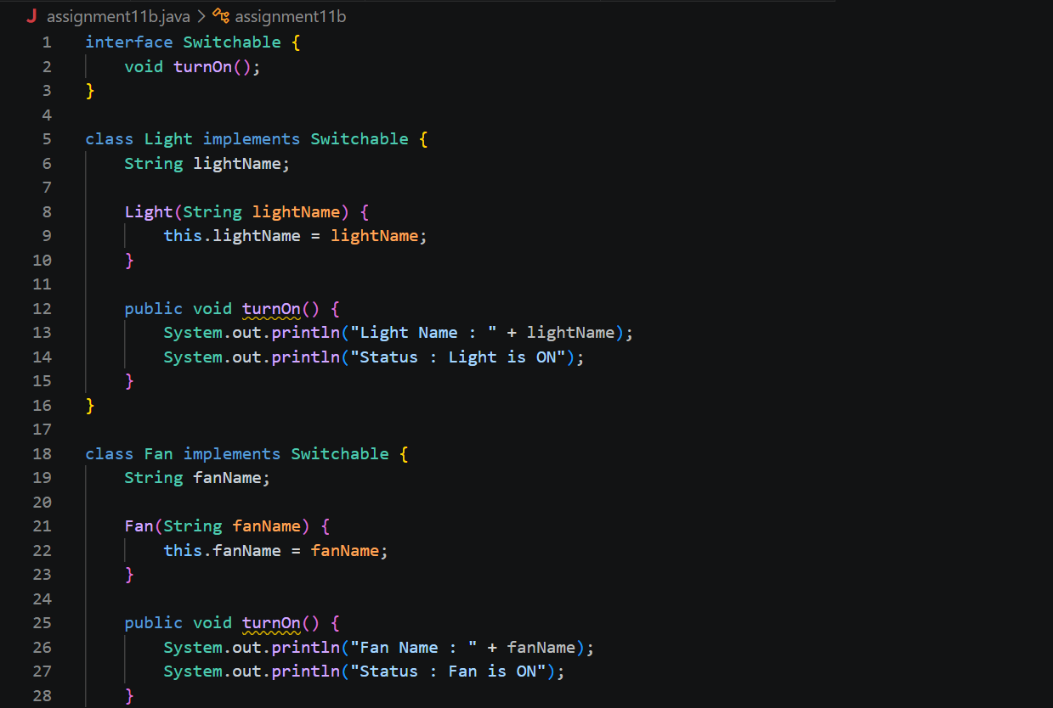

Output
